

**LAB-MID-EXAM**

**Name of Assignment:** Online Shopping and Banking App Class Diagram.

**Title: System Analysis & Design**

**Course Code: CSE-325**

**Submitted to:**

**Supta Richard Philip**

**Senior Lecturer**

**Department of CSE**

**City University, Bangladesh.**

**Submitted by:**

|  |  |
| --- | --- |
| **Name** | **: Sharmin Akther** |
| **ID No.** | **: 171442591** |
| **Program** | **: B.Sc in CSE (Eve)** |
| **Semester** | **: 7th Semester** |
| **Date of assigned** | **: 27/05/2019** |
| **Due Date** |  |

**Class Diagram of Online Shopping**

The agile software methods and development is practices based on approach empowered with values, principles and practices which make the software development process easier and in faster time. Agile method which includes methods like Extreme programming, Feature Driven Development, Scrum, etc. are more coming into the software development world. There has been a remarkable importance in the field of agile software development approaches in the recent past. This is because of the fastness that agile approaches bring in the life cycle of software development. This interest in the field shows that there are benefits and non-benefits to obtain through successful implementation of agile methods. This paper has been carried with the distinct objectives of examine and gain insights into the current agile methods and practices, understanding how each of phases in each agile methods works and how agile system development life cycle works. And in this paper it has been highlighted some of difference between Traditional Development and Agile Development.

**Class Diagram of Online Shopping**

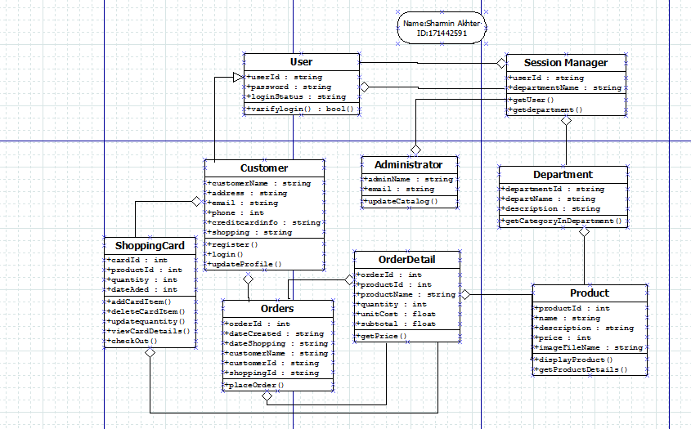

**Class Diagram of Banking App.**

Agile method which includes methods like Extreme programming, Feature Driven Development, Scrum, etc. are more coming into the software development world. There has been a remarkable importance in the field of agile software development approaches in the recent past. This is because of the fastness that agile approaches bring in the life cycle of software development. This interest in the field shows that there are benefits and non-benefits to obtain through successful implementation of agile methods. This paper has been carried with the distinct objectives of examine and gain insights into the current agile methods and practices, understanding how each of phases in each agile methods works and how agile system development life cycle works. And in this paper it has been highlighted some of difference between Traditional Development and Agile Development.

**Class Diagram of Banking App.**

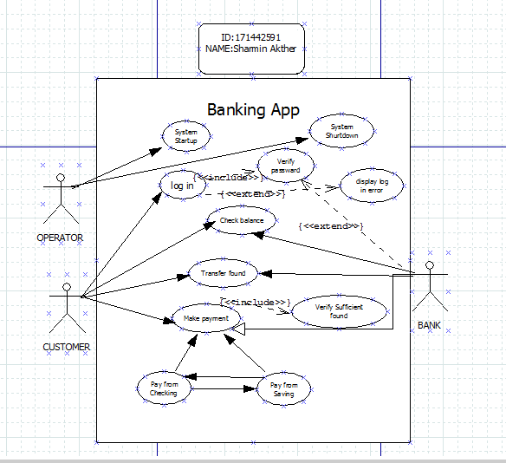

**Reference:**

**Class Diagram of Online Shopping:**

[https://www.researchgate.net](https://www.researchgate.net/)

[https://creately.com](https://creately.com/)

[https://www.pinterest.com](https://www.pinterest.com/)

[http://www.javaengineeringprograms.com](http://www.javaengineeringprograms.com/)

**Class Diagram of Banking App:**

[https://www.researchgate.net](https://www.researchgate.net/)

[https://www.google.com](https://www.google.com/)

[https://www.conceptdraw.com](https://www.conceptdraw.com/)

[https://www.tutorialspoint.com](https://www.tutorialspoint.com/)